

**Year 12 ATAR Human Biology**

**Stage 4 2019**

**Assessment Task 14**

**Test 5 – Evidence for Evolution**

**Name:** ……………………………………..

**Teacher:** ………………………………….

|  |  |  |
| --- | --- | --- |
| Part A | Multiple Choice Section | / 10 |
| Part B | Short Answer Section | / 45 |
| TOTAL | | / 55 |
| PERCENTAGE | | % |

**TEST 6: EVIDENCE FOR EVOLUTION: PART A – MULTIPLE CHOICE ANSWER SHEET**

***Place an X through the correct response***

1. [A] [B] [C] [D] 6. [A] [B] [C] [D]

2. [A] [B] [C] [D] 7. [A] [B] [C] [D]

3. [A] [B] [C] [D] 8. [A] [B] [C] [D]

4. [A] [B] [C] [D] 9. [A] [B] [C] [D]

5. [A] [B] [C] [D] 10. [A] [B] [C] [D]

/ 10

**Part B – Short Answers (45 marks)**

**Please write your responses in the spaces provided.**

1. Besides the study of fossils, much of the evidence for evolution has come from comparative studies. The diagrams below show an example of one of these methods. They show the appearance of several vertebrate pentadactyl limbs.

a) Name and describe the specific type of comparative study being illustrated in these diagrams. [2]

b) Explain how this method can provide support for the theory of evolution. [1]

c) More recent methods have involved biochemical studies which examine similarities and different at the molecular level. Included in these are the studies of DNA and protein in different species.

Explain how the study of proteins can provide evidence for evolution. [2]

2. The following diagram shows three (3) rock samples taken from three (3) different sites. Each of the layers of rock contains a fossil.

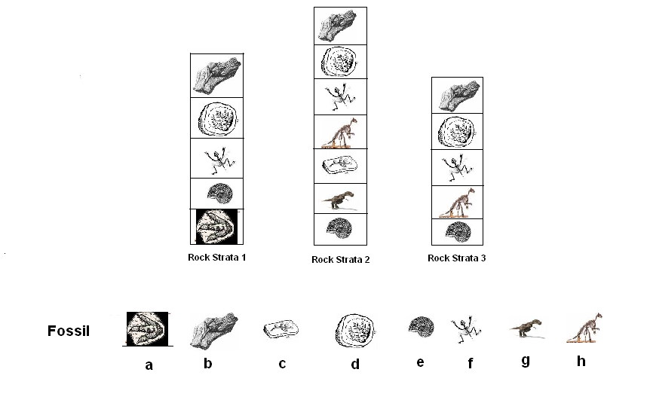

a) What is the name given to this method of studying rock layers in archaeology? [1]

b) Which of the digs sites (1,2 or 3) contains the oldest layers? [1]

c) How do you know it is the oldest? [1]

d) What is the name given to a group of fossils that is found in different parts of the world and indicates a specific time periods? [1]

e) Use the information to place the fossils in order from oldest to youngest. [1]

3. a) If a skull was found in sedimentary rock deposits, and some tools were also found, explain how fluorine dating could be used to decide whether the skull and the bone tools were of the same age. [2]

b) Explain if the dating method in Question 3.a is an absolute or relative dating technique and what each of those terms mean. [2]

c) If a skull was dated at 50 000 years and another was dated at 200 000 years, which skull could have been dated using radiocarbon dating? Explain your answer in full. [3]

d) Explain how a fossil could be formed? [3]

4. Carbon-14 dating techniques are commonly used methods for fossils dating. C-14 has a half-life of 5730 years.

a) Graph the decay curve of half-lives versus percentage of C-14 remaining. Carefully label the axes and indicate the values of each axis. [5]



b) Making specific references to your graph, explain what a half-life is and the important of isotope decay rates to the most accurate dating of fossils. [4]

c) Potassium-40 (K-40) is another radioisotope used in dating fossil objects. Given that the half-life of K-40 is 1.25 x 109 (1 250 000 000) years and what you know about this dating method, explain the circumstances under which you would use K-40 rather than C-14 to estimate the age of a fossil. [4]

5. The rows of diagrams below show the appearance of a number of vertebrate embryos and the adult form. Use this information to provide detailed answers to the following questions.

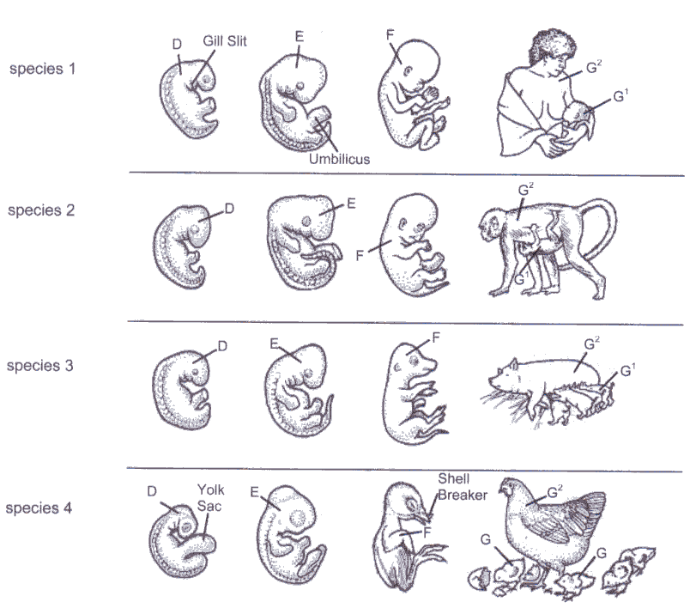

a) What process is illustrated in each row of diagrams? [1]

b) When comparing this process among the four species above, what two (2) generalisations are clear? [2]

c) Explain how these generalisations may be used to support the theory of evolution. [2]

6. Comparative studies of DNA have provided further evidence of evolution.

a) Discuss how Endogenous Retroviruses (ERVs) are helping scientists track DNA back through our common ancestors. [3]

b) What is mtDNA? Explain why it is a useful tool in providing evidence for evolution. [4]

**END OF TEST**

**Year 12 ATAR Human Biology Test 5 – Evidence for Evolution**

**Multiple-Choice Question Booklet**

**Please mark your answers on the Multiple-Choice Answer Sheet provided.**

**Part A – Multiple Choice (10 marks)**

1. The following diagrams show the sequences of rock strata from four locations.

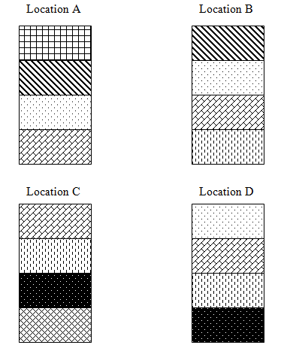

Which location appears to have the oldest stratum?

a) A

b) B

c) C

d) D

2. Radiocarbon (C-14) dating is a useful tool for studying our past. However, C-14:

a) Is only able to date fossils and artefacts much less than 100 000 years

b) Relies on the decay of atoms into argon gas which gets trapped in rocks, so dates are sometimes inaccurate.

c) Relies on the decay of carbon atoms and only about 1 atom in 1012 is radioactive.

d) Cannot be used on metals, bone or limestone sediments.

3. Which of the followings lists of events would be most suitable for fossil formation to occur?

a) Rapidly buried specimen, in wet acidic soil with a large supply of oxygen.

b) Slow burial of hard bodied specimen, by volcanic eruption.

c) Rapidly buried specimen, in alkaline soil with no available oxygen.

d) Rapidly buried soft-bodied specimen, in volcanic ash.

4. The diagrams below represent sedimentary rock strata from two different paleontological sites.

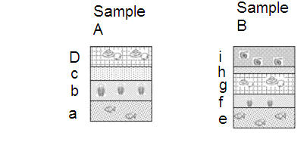

Based on these diagrams, it would be reasonable to conclude that fossils in:

a) Strata b are the same age as fossils in strata e.

b) Strata a are younger than fossils in strata f.

c) Strata D are younger than fossils in strata f.

d) Strata i are older than fossils in strata g.

5. An object found among prehistoric remains, which was clearly made by humans, is best described as:

a) A fossil.

b) An artefact.

c) An artifice.

D) Evidence for culture.

6. Molecular genetics studies have established that modern humans and chimpanzees have approximately 98.7% of their DNA in common. Chimpanzees share 98.4% with gorillas. Gorillas and humans share 98.3%. A reasonable interpretation of these data is that:

a) Chimpanzees and gorillas shared a common ancestor more recently than chimpanzees and humans.

b) Gorillas and humans shared a common ancestor more recently than chimpanzees and gorillas.

c) Chimpanzees and humans shared a common ancestor more recently than chimpanzees and gorillas.

d) One cannot measure evolutionary divergence using DNA sequence overlaps.

7. When dating fossils, the law of Superposition states that:

a) Accurate levels of radioisotopes must be obtained.

b) Older fossils occur in deeper layers of rocks.

c) Fluorine levels are highest in old fossils.

d) Older fossils are not as well preserved as younger fossils.

8. Which of the following is not considered a vestigial organ?

a) The nictitating membrane of the eye.

b) The segmentation of abdominal muscles.

c) The pyramidalis muscle.

d) The femur.

9. The half-life of carbon-14 is 5730 years. How much of the original carbon-14 is left in a fossil specimen that is dated at 17190 years?

a) 12.5%

b) 25%

c) 50%

d) 75%

10. The depth of fossils in different layers of an archaeological site gives information on the:

a) Relative age of the fossils.

b) Absolute age of the fossils.

c) Types of species of animals living at the same time.

d) Number of species of animals living at the time.

**END OF PART A**